**Week 3 – 32 – Practise Problem Solution**

**Name: Ramesh Harisabapathi Chettiar**

**Roll Number: RA2411030010263**

**Course: Networking and Communications**

**Semester: 3**

**Date of Submission: 29/08/2025**

PRACTISE PROBLEM 1:

Create a program that demonstrates the concept of classes and objects using a

real-world analogy.

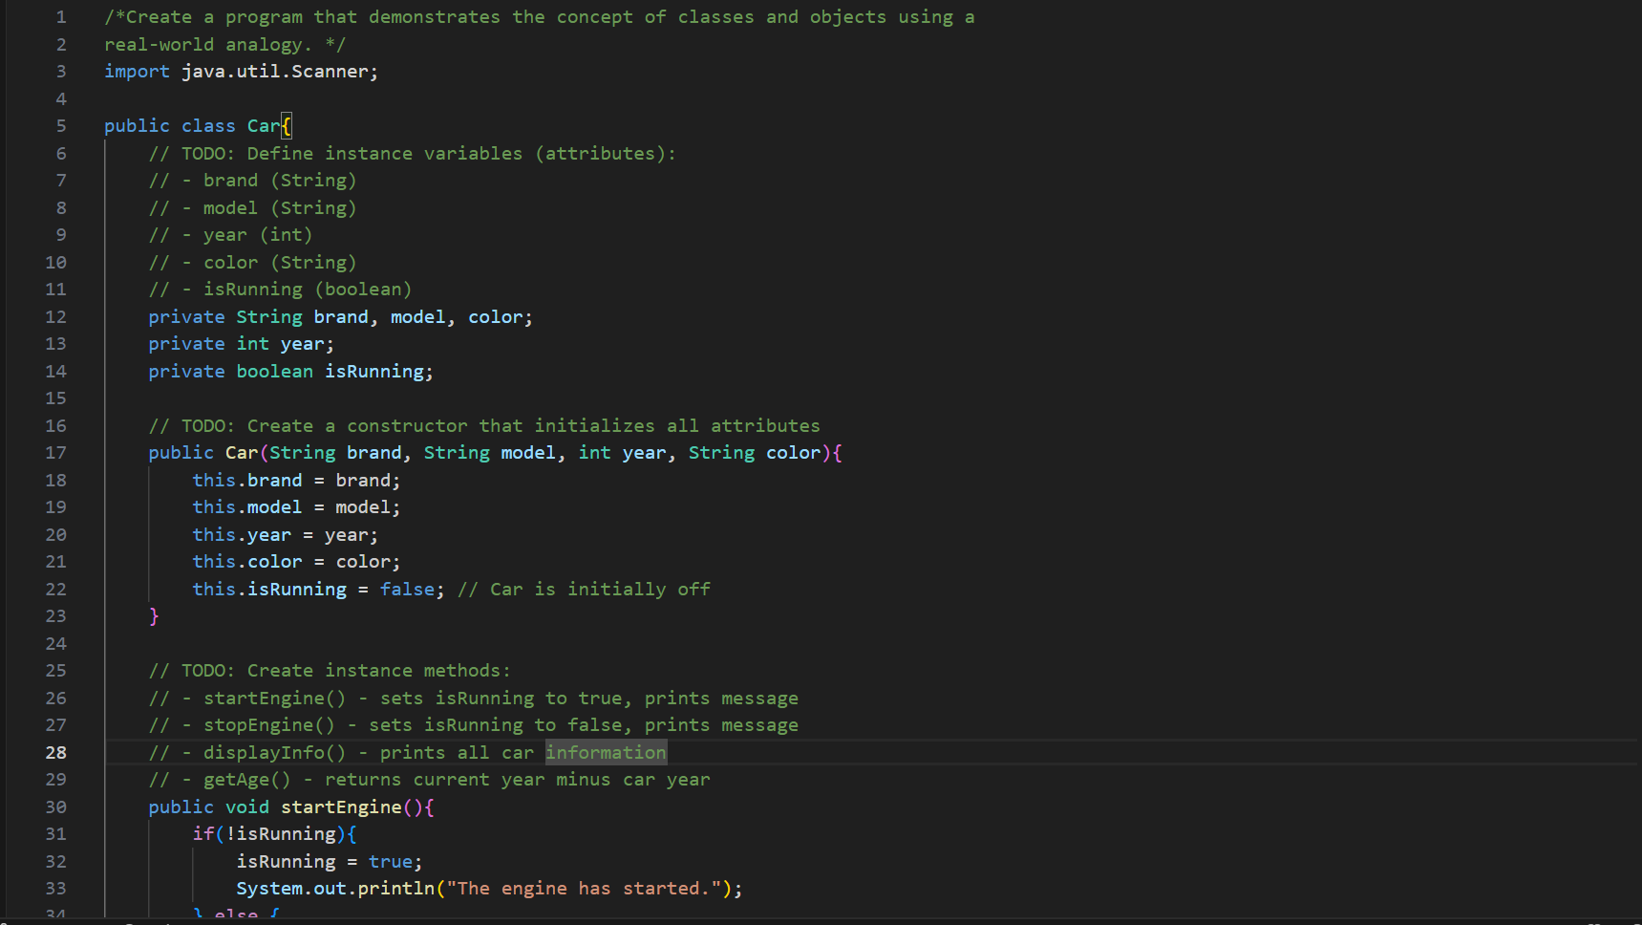 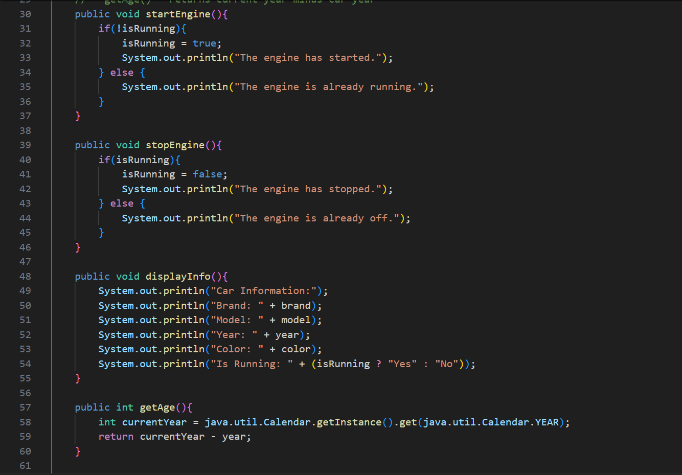 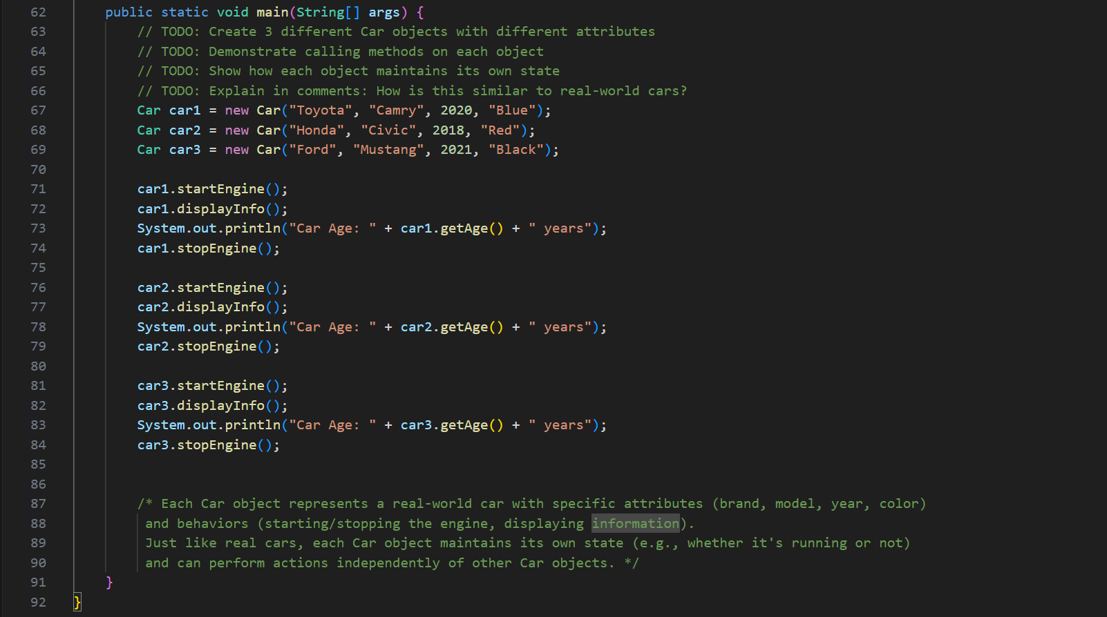

OUTPUT

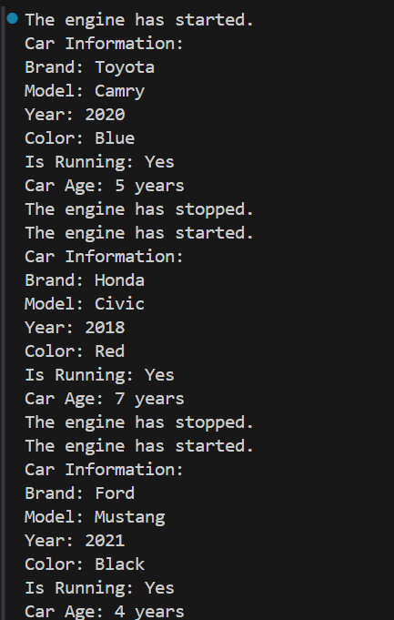

PRACTISE PROBLEM 2:

Create a Student class that demonstrates proper class structure and object instantiation.

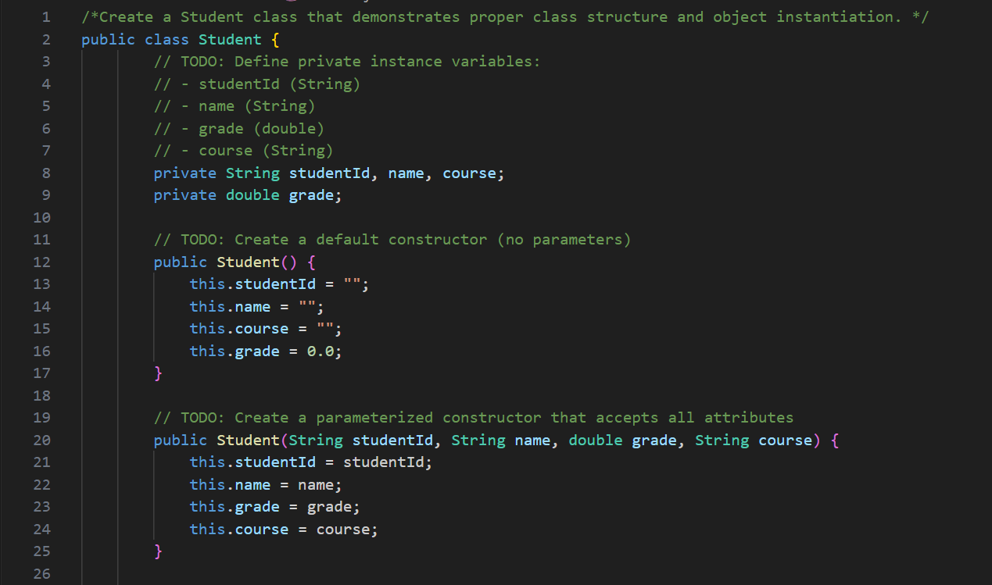  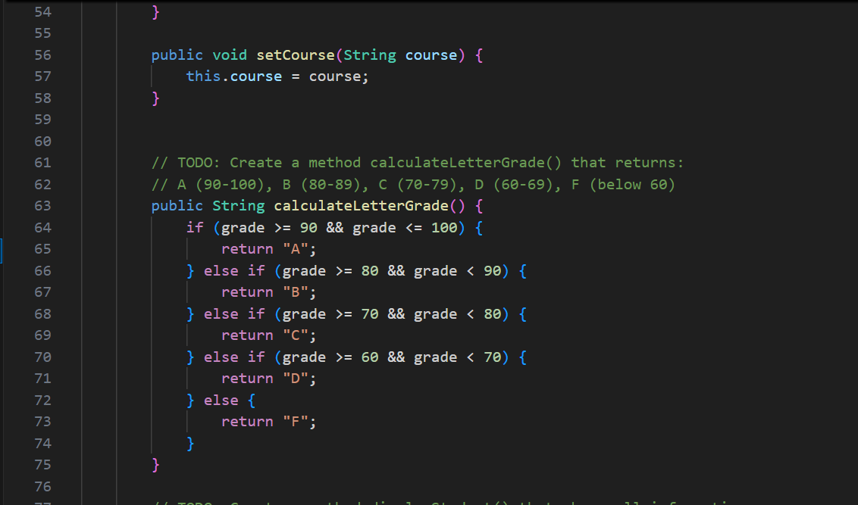 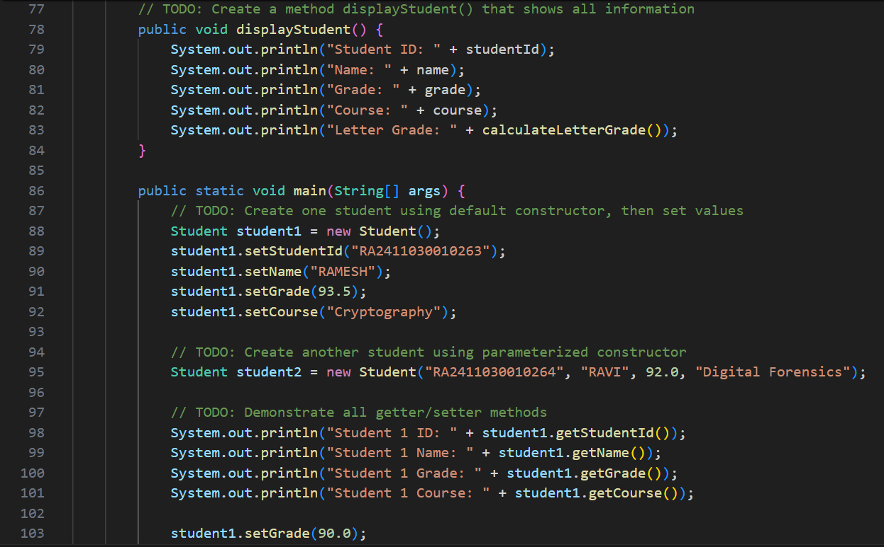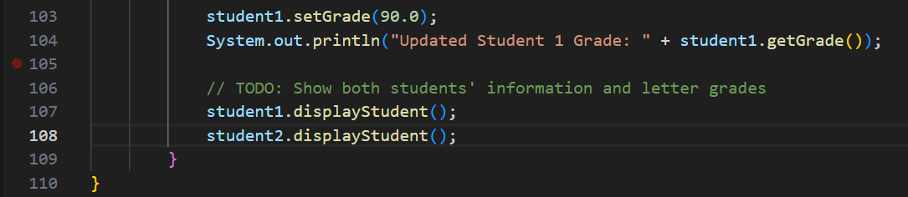

**OUTPUT:**

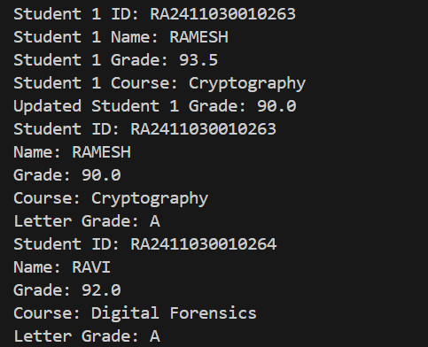

**PRACTISE PROBLEM 3:**

**Create a program that clearly demonstrates the difference between instance and static**

**members.**

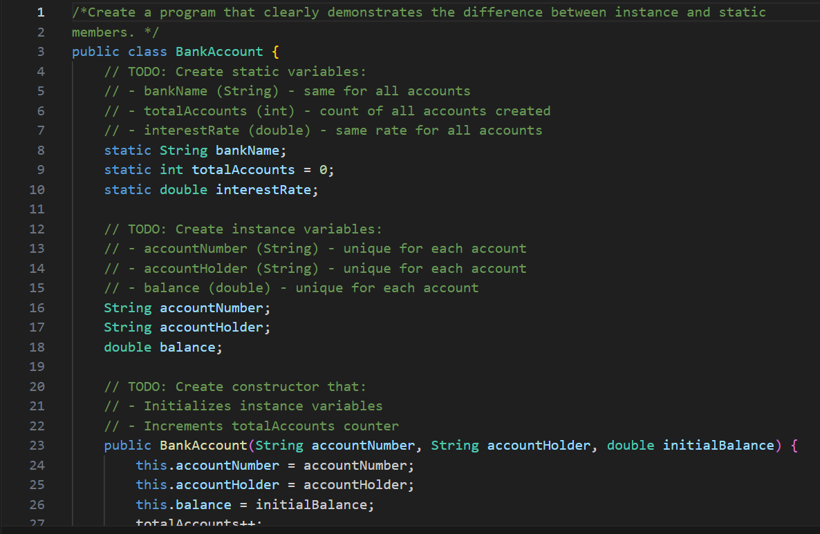

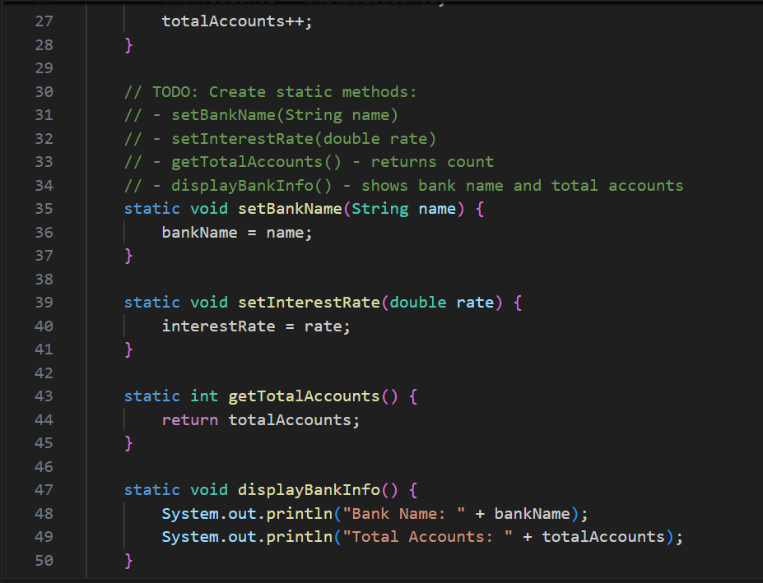 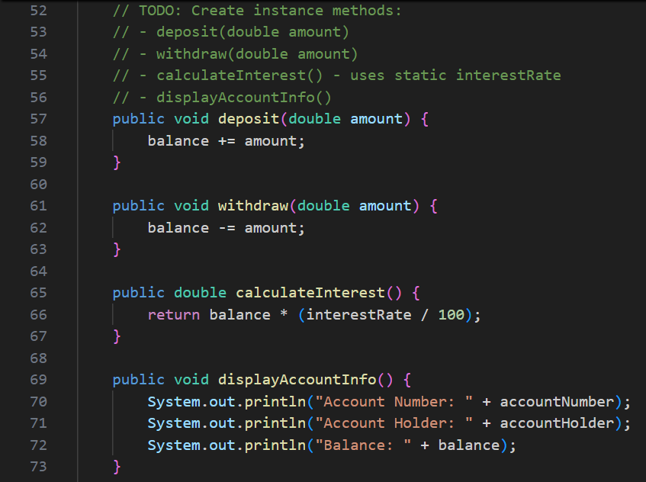

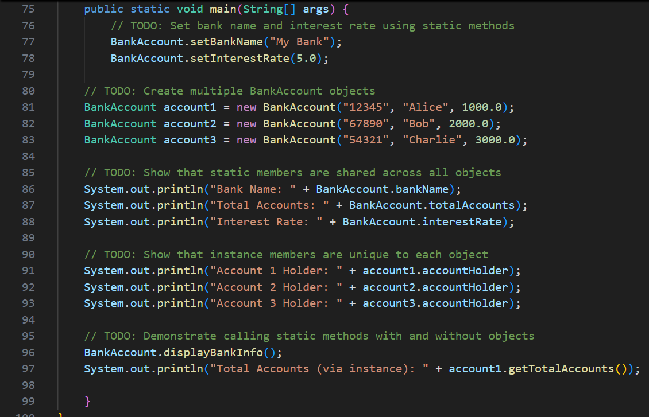

**OUTPUT:**

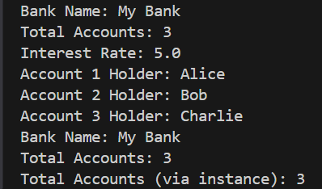

PRACTISE PROBLEM 4:

Create a base class and demonstrate how OOP promotes code reusability.

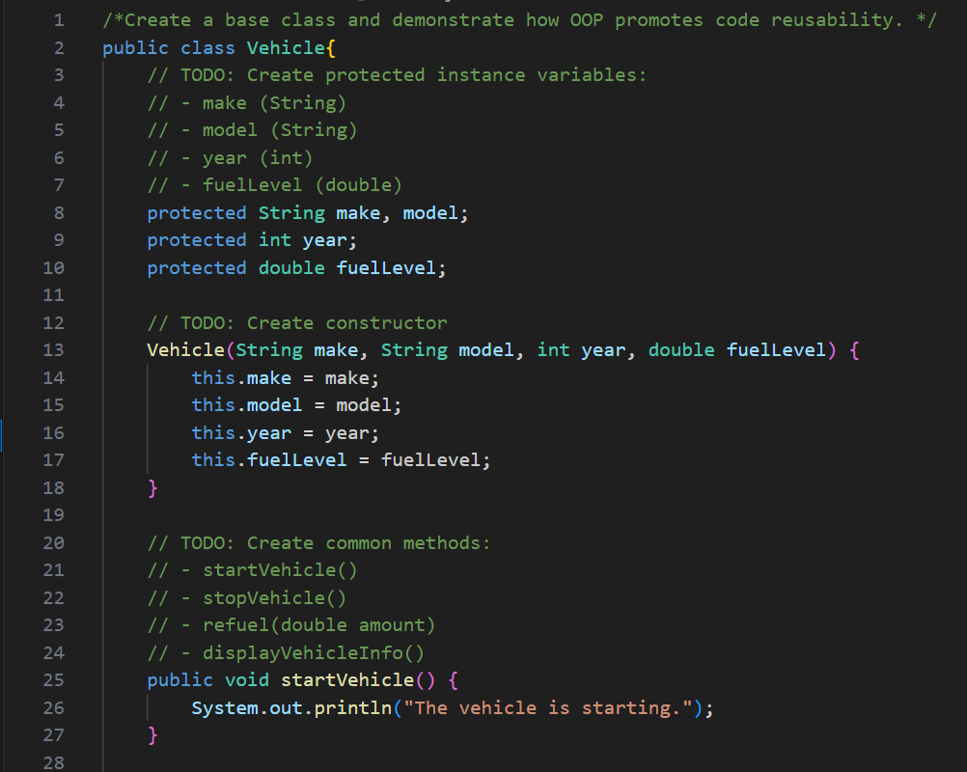 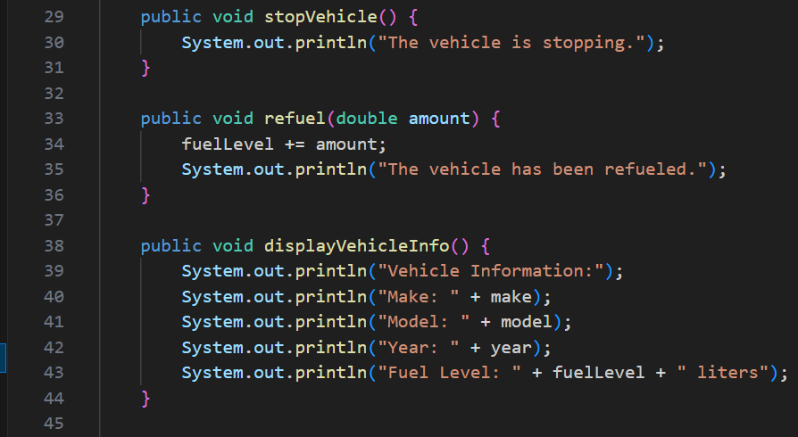

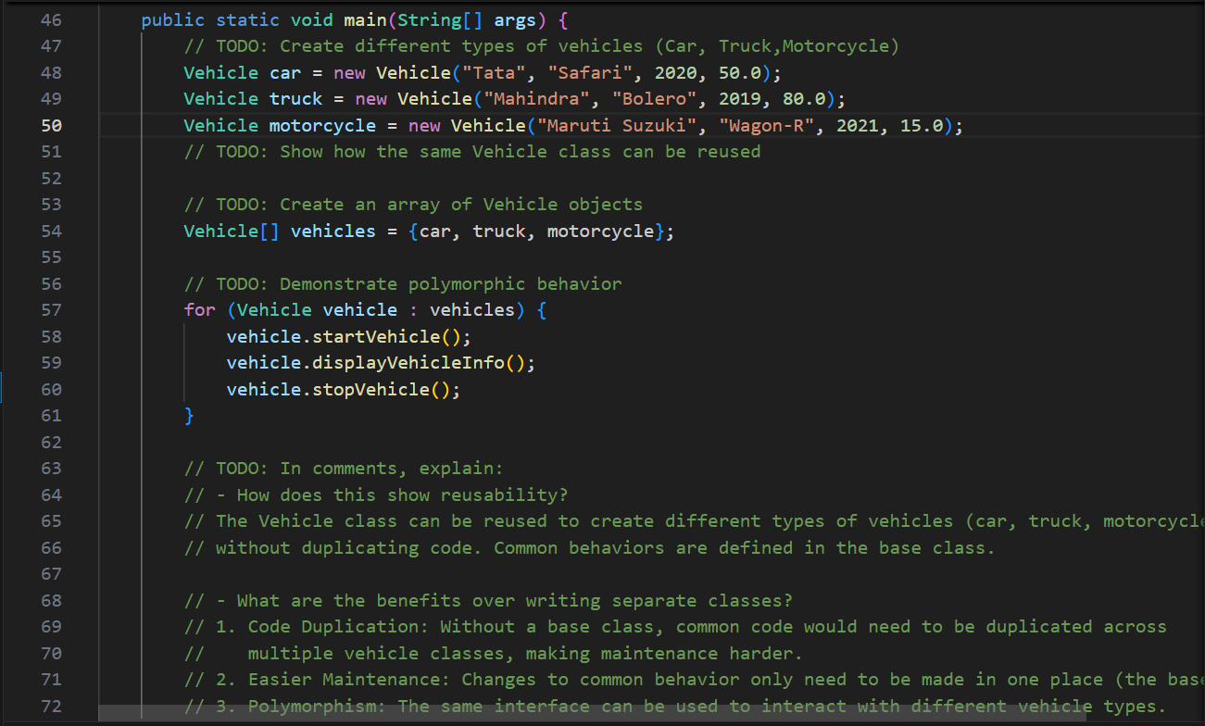

**OUTPUT:**

